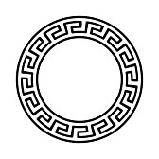

Dionysus

I imagine him to look like….