Earth History
Earth Science Study Guide Study GUide
Plate Tectonics and Seas of the Paleozoic and Mesozoic Eras
Study Tip
Paleozoic Plate Tectonics
Remember that the continents needed to come together before they split apart.
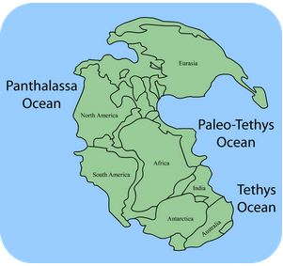
- The Paleozoic era began with the splitting up of the supercontinent Rodinia, and ended with the formation of the supercontinent Pangaea.
  - Pangaea was the last supercontinent on Earth, and was formed approximately 250 years ago.
- Continents collided together to form mountain ranges through orogeny, a mountain-building process.
Mesozoic Plate Tectonics
- Approximately 180 million years ago, Pangea began to break apart into multiple continents.
- Moving continents collided with island arcs and microcontinents, forming mountain ranges on the continents’ edges.
Pangea was the last supercontinent on Earth.
- The Panthalassa Ocean separated into individual, interconnected oceans that we see today.
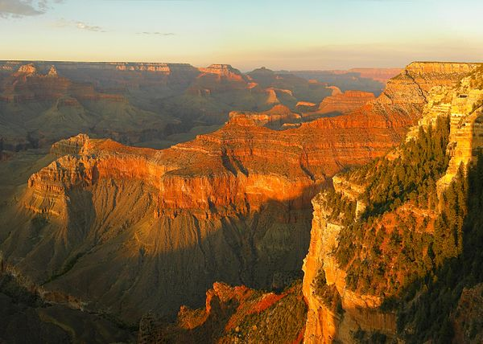
Paleozoic and Mesozoic Seas
- The most important events of the Paleozoic and Mesozoic eras were the changes in sea level.
  - Marine transgression is when sea level rises over land and marine regression is when sea level retreats from land.
  - These two processes leave behind rock layers called facies.
The Grand Canyon shows sedimentary facies, which show where prehistoric oceans used to be.
  - Four complete transgression/regression cycles occurred during the Paleozoic era and two more occurred during the Mesozoic era.
Concept Check
- What was the plate tectonic activity like during the Paleozoic era and the Mesozoic era?
- What is orogeny?
- What is marine transgression and regression? What do they leave behind?

